**C_Assignment_3b**

**ARR/01 char *swap_elements(<i/p array>, <index>) should swap the content of first element (at index 0) with contents of element at given index and return a pointer to the element at given index**

**Ans:**

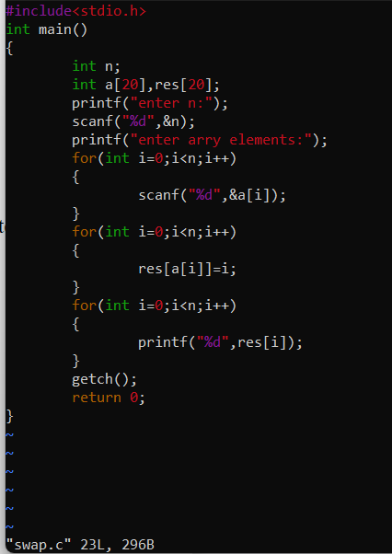

**ARR/02 Int isVowel(<char to test>) should return EXIT_SUCCESS for vowel character and EXIT_FAILURE for non-vowel character**

**Ans:**

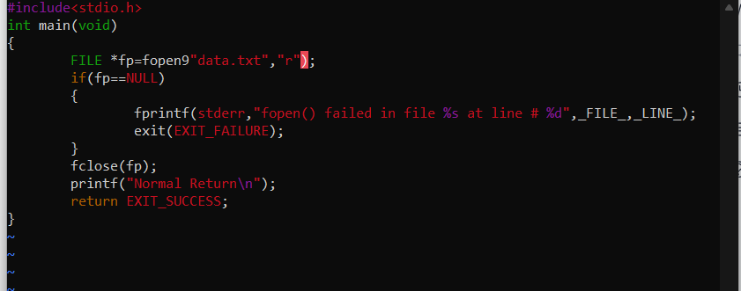

**ARR/03 char *remove_vowel(<i/p array>, <index>) should process the string at given index in array, remove all vowel characters, shift the remaining non-vowel characters and return the pointer to the updated string**

**Ans:**

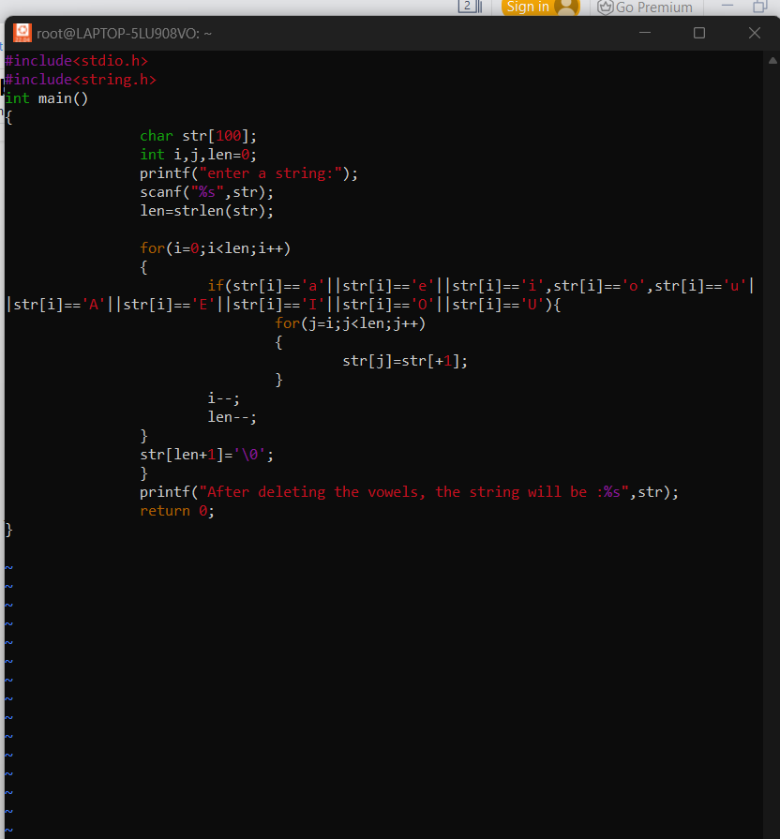

**ARR/04 char *mystrcat(char *s1, char *s2 ) should concat s2 with s1 and return the address of s1 without using strcat()**

**Ans:**

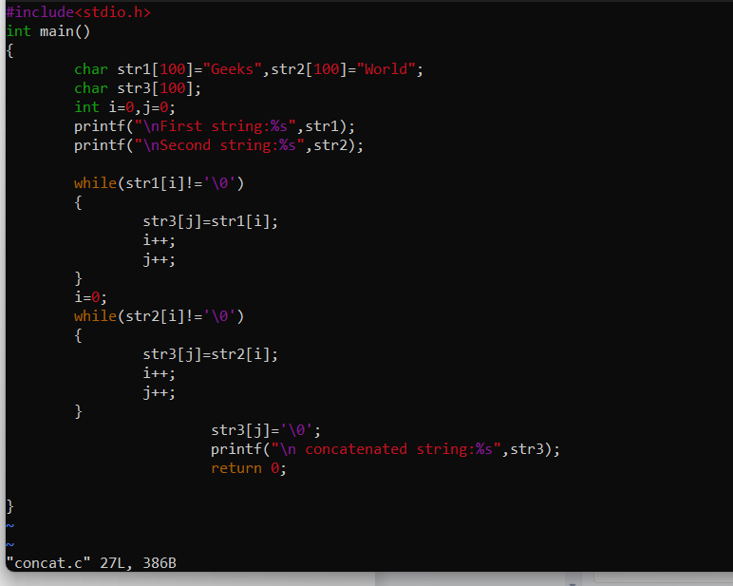

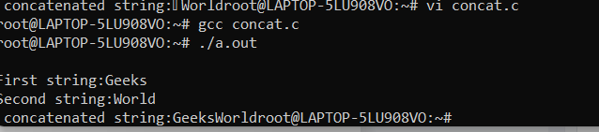

**ARR/05 Should implement display() to traverse and display the contents of array**

**Ans:**

